ANNOUNCEMENTS
Upcoming Sunday worship at 10:00 AM:
November 27, First Sunday in Advent
Help us decorate our sanctuary during our worship time at 10 AM. (No Zoom)
December 4, Christmas Caroling
Meet at 10 AM at the church to go a-caroling with Erika Neuman. (No Zoom)
December 11, Presentation: “John Mason Neale: Cleric, Benefactor, Writer of Carols”
December 18, Pastor Melissa’s last Sunday with us
~~~
December 24, 7 PM, Christmas Eve service of lessons and carols with Pastor Melissa

Pastor Melissa is on leave until December 15. Until then Linda Brewster is available for pastoral emergencies or funerals. Linda Brewster’s phone: 207-807-2210.

PRAYER LIST
For the families of Linda White, Frank Mansfield, Cevat Erder, Jeremy Putnam, Jason Kupetz and Mary Lee Hilly.
And for Deb Bowman, Elizabeth Burbine, Ed Gilchrist, Darren Hillicoss, Hobey Hinchman, Roy & Suzanne Jackson, Jessica, Jonathan, Carla Widlund Joyce, Scott Libby, Lisa, Beryl O’Neil, Bea Pettit, Helen Scott, Alison Shepherd, Juan Toj, Grace Warne, Craig Winslet,
Rev. Alijandro and the people of Guatemala; those who live with addiction or mental illness; veterans and those serving in the military; children who are hungry or abused; victims and perpetrators of domestic violence; refugees and those who are homeless; housing on Chebeague; our island school and families, the leaders of our country, children and families at the border, the Ukrainian people, those who experience hate because of their racial identity or sexual orientation, including Black, Asian, Hispanic, Middle-Eastern, Native American and LGBTQ+ folx, all impacted by COVID-19, those who are disabled, those who are ill, our new church, our environment, those who experience injustice in our world, and that all may know hope and love.
CHEBEAGUE COMMUNITY CHURCH

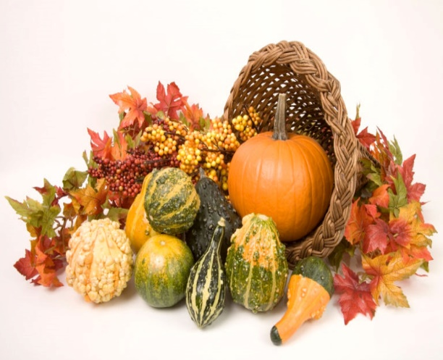

Welcome to worship!
November 20, 2022, 10:00 AM

Masking no longer required

258 North Road
Chebeague Island, ME 04017

Church office phone: 846-6987
Email: church.chebeague@gmail.com
Website: www.chebeaguechurch.org

ORDER OF WORSHIP, NOVEMBER 20, 2022

Gathering Music – Carillon

Lighting of Candles

Welcome

❉Call to Worship*
One: God is our refuge and strength, a very
present help in trouble.
Many: We gather to celebrate another day that God has kept us.
One: Therefore we will not fear, though the earth should change.
Many: We gather to bear witness to all that God has done for us.
One: Come, behold the works of God!

❉Unison Prayer of Transformation & Words of Grace*

Holy God, it’s so easy for us to get caught up in our humanmade divisions. Whether survival instincts or capitalistic drive, we separate ourselves from those who don’t look, think, or act like us. We unintentionally allow our differences to stain the beauty of your diversity. Our many different households, family structures, belief systems, and various identities become tools of divisiveness rather than gifts of the divine.

[a space of silence is observed]

Even when we cling to the things that unnecessarily separate us, God unscatters us. No matter who we are or what has brought us to this very moment, God chooses to love us back to wholeness, individually and communally. Hallelujah and amen!

❉Hymn Come Ye Thankful People, Come UMH 694

❉Please stand as you are able and join in the parts marked in bold.

*From Gathered: Service Prayers for the Reign of Christ Sunday by The Rev. Phiwar Langeni
Scripture Readings:

Psalm 46 (NIV)

Jeremiah 23 1-6 (The Message)

Leader: A Word of God that is still speaking,
People: Thanks be to God.

Reflection

❉Hymn

He Leadeth Me: O Blessed Thought UMH 128

Joys and Concerns and Prayer List
Lord in your mercy, hear our prayer.
God for your goodness, we give you thanks.

Prayer and Lord’s Prayer

Announcements

Stewardship video

❉Prayer of Dedication connectusfund.org)

God, our hearts overflow with thanksgiving to you. You are infinitely good to us. Your creation is so magnificent – it gives us pleasure and supplies our needs for food and water and light and warmth. And you have supplied salvation through Jesus. You supply our spiritual needs through communion with You, through our spiritual armor, our spiritual gifts, and your indwelling Holy Spirit. Accept these pledges and offerings we give you today as a “thank offering” for your immeasurable blessings. Amen.

❉Benediction*

~~~~~

Today’s worship leader: Lola Armstrong
Lector: Denise Hamilton Computer IT: Cheryl Stevens

