ANNOUNCEMENTS

Upcoming Sunday worship at 10:00 AM in the church:
December 18, Pastor Melissa’s last Sunday with us
December 25, Christmas Day, no worship service
~~~
December 24, 7 PM, Christmas Eve service of lessons and carols with Pastor Melissa in the sanctuary and Zoom

PRAYER LIST
For the families of Chris Howard, Marshall Bowen, Jan Wentling, Deborah Knight Moulton, Dick Hilly, Linda White, Frank Mansfield, Cevat Erder, and Jeremy Putnam. And for Deb Bowman, Elizabeth Burbine, Tom Calder, Ed Gilchrist, Darren Hillicoss, Hobey Hinchman, Roy & Suzanne Jackson, Jessica, Jonathan, Carla Widlund Joyce, Scott Libby, Lisa. Emily Muller, Marjorie Munroe, Beryl O’Neil, Bea Pettit, Helen Scott, Alison Shepherd, Juan Toj, Grace Warne, Craig Winslet,
Rev. Alijandro and the people of Guatemala; those who live with addiction or mental illness; veterans and those serving in the military; children who are hungry or abused; victims and perpetrators of domestic violence; refugees and those who are homeless; housing on Chebeague; our island school and families, the leaders of our country, children and families at the border, the Ukrainian people, those who experience hate because of their racial identity or sexual orientation, including Black, Asian, Hispanic, Middle-Eastern, Native American and LGBTQ+ folx, all impacted by COVID-19 and RSV, those who are disabled, those who are ill, our new church, our environment, those who experience injustice in our world, and that all may know hope and love.

CHEBEAGUE COMMUNITY CHURCH
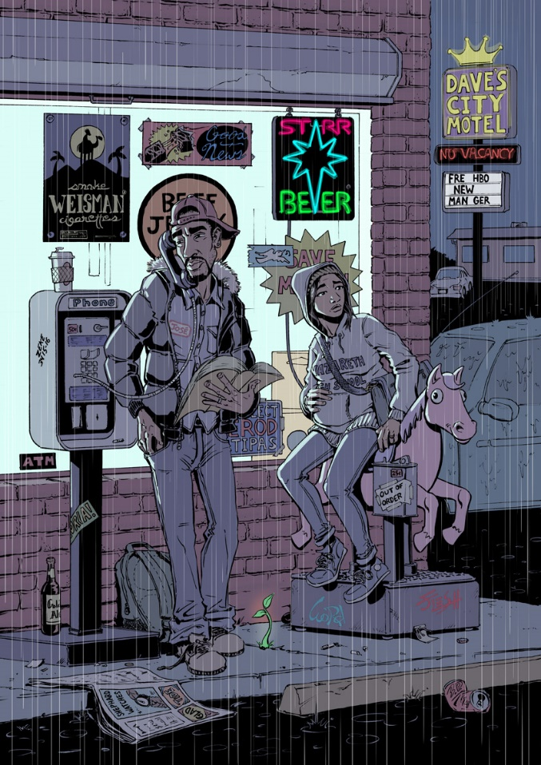
Image by Everett Patterson, “Jose y Maria”

Welcome to worship!
December 18, 2022, 10:00 AM
Masking no longer required
258 North Road
Chebeague Island, ME 04017
Church office phone: 846-6987
Email: church.chebeague@gmail.com
Website: www.chebeaguechurch.org
ORDER OF WORSHIP, DECEMBER 18, 2022
Gathering Music
Welcome
Lighting of Candles
*Call to Worship (enfleshed, adapted)
L: Wonder breaks through despair in unexpected ways.
P: Rejoice!
L: Divine Creativity is courageous in Her Way-Making.
P: Rejoice!
L: Our God consoles the brokenhearted.
P: Rejoice!
L: When we sleep, God knocks on the doors of our dreams.
P: When we wake, God lures us towards radical hope.
L: When we sing, God spreads out joy like a song.
P: Rejoice! God is with us.
*Hymn Arise, Shine FWS 2005
Prayer of Confession (Rev. Thom Shuman, Lectionary Lituriges, adapted)
Come now, Reconciler of the nations, for our world, our lives, need your peace more than ever before. Come, Caller to discipleship, for we long to let go of our self-interest and narcissism. Come, Word Gifter, for we hunger to hear your voice once again, ever always. Come, Servant of the poor, so we notice you in all those we push past in this hectic season.
Come, Silence of our nights and Holiness of our hearts, and forgive us for commodifying your compassion, turning your hope into hollow words, and diminishing your dreams for ourselves and for your world. May we find our way to the One born simply, born gracefully, for us – Jesus, the Child of wonder and life.
Silence is kept for reflection, confession, and meditation
Words of Assurance (enfleshed, adapted)
L: God who takes on flesh, you are not confined by the rigid and narrow. Your love is expansive and flexible. Your compassion is deep. Your Wisdom is ancient and always being reborn. May we be open to you in all your manifestations, familiar and new, that we might not miss the miracle of your dwelling with us.
P: We are a forgiven and thankful people, freed to love in ways that transform the foundations of this world. Thanks be to God!
Scripture Reading Matthew 1:1-18
Leader: A Word of God that is still speaking,
People: Thanks be to God.
Sermon
Joys and Concerns
Concerns: Lord in your mercy, hear our prayer.
Joys: God for your goodness, we give you thanks.
Prayer with Lord’s Prayer
Communion see insert
Announcements
*Prayer of Dedication (enfleshed, adapted)
Holy One, with gratitude we anticipate your presence with us. In the depths of life, you meet us: In our grief, in our fears, in our capacities for good and for evil, you draw near. You come to us with compassion and vulnerability, revealing the way of Love that liberates. Bless us and what we share with you and others, and encourage us in our love for each other. Amen.
*Hymn Walk in the Light
*Benediction

*Please stand as you are able and join in the parts marked in bold.

