Chebeague Community Church
Christmas Eve Service of Candles and Carols
December 24th, 2022

WE GATHER TO WORSHIP
Welcome
*Call to Worship
One: God of creation, shaper of seas and stars, of planets and
people, of sacred beauty and sacred being -
All: This God is here with us.
One: God, born in Bethlehem, gurgling, crying, laid in a manger -
All: This God is here with us.
One: God, breath of the universe, flickering, dancing in the candle flame -
All: This God is here with us.
One: God, Immanuel, Divine-in-Flesh, among us, within us
All: We bring ourselves and our dreams, for we want to be here with you.
*Hymn O Come, All Ye Faithful, v. 1-3, 6 UMH #234
*Unison Prayer
Holy One, you have appeared in the flesh, bringing redemption to all, your glory is made known in this newborn child, this living, blessed hope. Tonight we sing a new song—
a song of justice, righteousness, and endless peace. Gift of God, beautiful Christ-child, we welcome you! Let love be born anew in our hearts on this joyous night. Amen.
WE LISTEN TO GOD’S WORD
Special Music O Holy Night
Reading Isaiah 9:2-7 Michael Yosua-Davis
Lighting the Candle of Hope
*Hymn Lo, How A Rose E’er Blooming UMH #216
Reading Luke 1:26-38 Adia Ameswright
*Hymn It Came Upon the Midnight Clear, v1 and 4 UMH #218
Reading Matthew 1:18-25 Cathy MacNeill
Lighting the Candle of Love
*Hymn O Little Town of Bethlehem, v1 and 4 UMH #230
Reading Luke 2:1-7 Betsy Gaston
*Hymn What Child Is This, v 1 and 2 UMH 219
Time for the Children
Reading Luke 2:8-14 Polly Wentworth
Lighting the Candle of Joy
*Hymn Angels We Have Heard on High UMH #238
Reading Luke 2:15-21 Mary Holt
*Hymn In the Bleak Midwinter, v1, 3 and 4 UMH #221
Reading Matthew 2:1-12 Denise Hamilton
Lighting the Candle of Peace
*Hymn The First Noel, v1, 2 and 5 UMH #245
Reading John 1:1-14 Rochelle Rice
Lighting the Christ Candle
*Hymn Joy to the World UMH #246
Lighting of the Candles
Please share the light of Christ with your neighbor by holding your light steady while your neighbor tips their candle to ignite their wick. We will join together in singing “Silent Night.” You may leave your candle on the table in the entry as you leave.
*Hymn Silent Night UMH #239 or insert
*Benediction
One: Mysterious God, confounding our expectations, meeting us where we least expect to find you:
All: Stay with us now.
One: Child of the manger, sharing our humanity, loving skin and bone:
All: Stay with us now.
One: Source of Life, birth of God within our own experience:
All: Stay with us now.
One: Stay with us in our beings, stay with us on our journeys
All: Walk beside us, live within us, lead us in love.

Announcements
Rev. Mary Jane O'Connor-Ropp has agreed to provide pastoral coverage for emergencies or funerals for January through March. Many will remember Mary Jane as our pastor several years ago. She will also come to preach and serve communion once a month for those three months. Welcome back, Mary Jane!
Rev. Mary Jane O'Connor-Ropp's phone number: 207-604-7841

January Sundays in the Parish House!
January 1 Lock Kiermaier will present an illustrated program about Little Chebeague
January 8 TBA
January 15 TBA
January 22 Rev. Mary Jane O’Connor-Ropp – communion will be served
January 29 Membership Annual Meeting

Church Council meeting, Sunday, January 15 at noon, in-person at the Parish House and via Zoom.

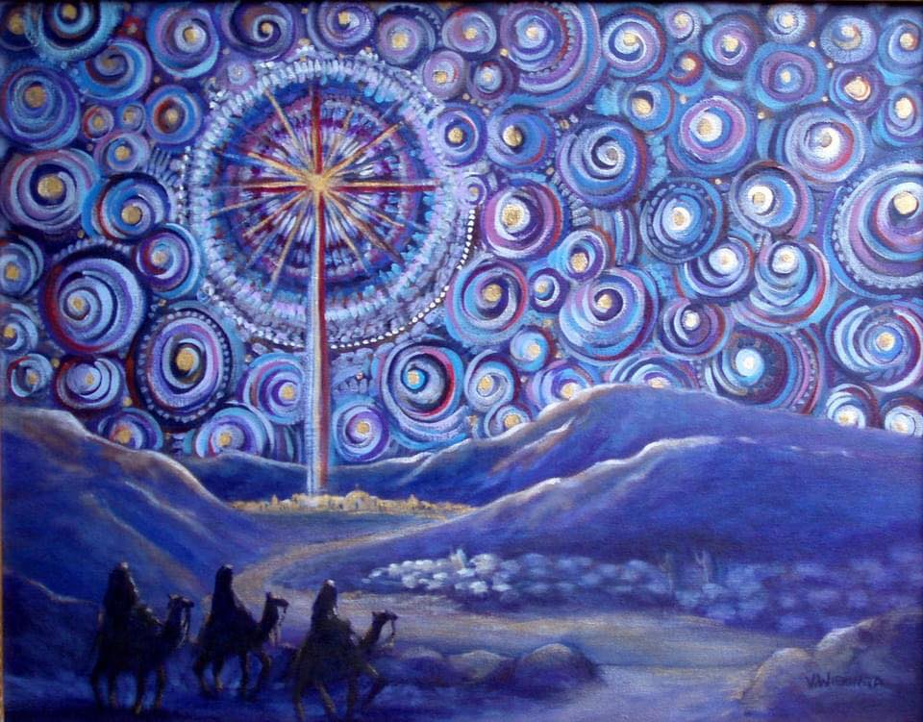
Image by Virginia Wieringa

Chebeague Community Church
Christmas Eve 2022
Service of Candles and Carols
7 PM

Silent Night
- Silent night, holy night,
all is calm, all is bright
round yon virgin
mother and child.
Holy infant, so tender and mild,
sleep in heavenly peace,
sleep in heavenly peace.
2. Silent night, holy night,
shepherds quake at the sight;
glories stream from heaven afar,
heavenly hosts sing Alleluia!
Christ the Savior is born,
Christ the Savior is born!
3. Silent night, holy night,
Son of God, love's pure light;
radiant beams from thy holy face
with the dawn of redeeming grace,
Jesus, Lord, at thy birth,
Jesus, Lord, at thy birth.
4. Silent night, holy night,
wondrous star, lend thy light;
with the angels let us sing,
Alleluia to our King;
Christ the Savior is born,
Christ the Savior is born!

Silent Night
1. Silent night, holy night,
all is calm, all is bright
round yon virgin
mother and child.
Holy infant, so tender and mild,
sleep in heavenly peace,
sleep in heavenly peace.
2. Silent night, holy night,
shepherds quake at the sight;
glories stream from heaven afar,
heavenly hosts sing Alleluia!
Christ the Savior is born,
Christ the Savior is born!
3. Silent night, holy night,
Son of God, love's pure light;
radiant beams from thy holy face
with the dawn of redeeming grace,
Jesus, Lord, at thy birth,
Jesus, Lord, at thy birth.
4. Silent night, holy night,
wondrous star, lend thy light;
with the angels let us sing,
Alleluia to our King;
Christ the Savior is born,
Christ the Savior is born!

